**Oyster Task Force Meeting Minutes**

**Tuesday, September 20, 2022, 1:00pm**

**New Orleans Lakefront Airport**

**6001 Stars and Stripes Blvd**

**New Orleans, LA**

**I.** Pledge of Allegiance

**II.** Roll call and introduction of guests

**Voting Members Present:**

Mitch Jurisich

Brad Robin

Brandt Lafrance

Matthew Slavich

Sam Slavich

Peter Vujnovich

Willie Daisy

Steve Pollock

**Voting Members Absent:**

Shane Bagala

Tracy Collins

Dan Coulon

Jakov Jurisic

Al Sunseri

**Non-Voting Members Present:**

Carolina Bourque

Justin Gremillion

Major Edward Skena

Sarah Roy in for Karl Morgan

Brian Lezina

**Non-Voting Members Absent:**

Harry Vorhoff

**III.** Peter Vujnovich motioned to approve the August 16, 2022 meeting minutes, 2nd by Brandt Lafrance. Motion carries.

Peter Vujnovich motioned to amend the agenda by adding item H to New Business, To Discuss the Final EIS on the Mid-Barataria Sediment Diversion, 2nd by Sam Slavich. Motion carries.

Peter Vujnovich motioned to approve the September 20, 2022 meeting agenda as amended, 2nd by Sam Slavich. Motion carries.

**IV.** Treasury Report

Remaining Fund Balance- $555,160

Remaining Budget Balance- $67,808

Peter Vujnovich motioned to approve the treasury report as presented, 2nd by Brad Robin. Motion carries.

**V.** Committee Reports

1. Public-Private Oyster Seed Grounds Committee- no report
2. Enforcement Report- Captain Bryan Marie is retiring from LDWF Enforcement the task force and industry thanks him for his service, Major Edward Skena is taking his place, also announced that Capt. Steve McManus is retiring as well.

July 28th – September 18th

**Region 4** (Iberia)

None

**Region 5** (Calcasieu and Cameron)

None

**Region 6**: (Terrebonne, Lafourche, Grand Isle)

Terrebonne

1-Violate sanitary code (logbook)

1-No vessel license

**5 sacks seized**

**Region 8**: (Jefferson, Plaquemines, St. Bernard, Orleans)

Plaquemines

2-Violate Sanitary Code-Log Book

Take Commercial Fish W/O Vessel License

Fail to fill out Oyster Tags Correctly

**12 Sacks Seized**

St Bernard

Violate Sanitary Code-No Waste Bucket

Fail to Display Proper Number on Vessel

Sell/But Commercial Fish W/O Wholesale Retail License

Fail to Maintain Records

Fail to Complete Trip Ticket

**0-Sacks Seized**

1. Legislative Committee Report- no report
2. Legal Committee Report- no report
3. Research Committee Report- no report
4. Coastal Restoration Report- no report
5. Marketing Committee Report- BMF is continuing to maintain marketing efforts and social media accounts as well as Oyster Task Force website
6. Health Committee Report- the Interstate Shellfish Sanitation Conference will be held in person, for the first time since 2019, on March 18-23, 2023 in Baton Rouge. Will have some ISSC proposals coming up and will possibly host another OTF Health Committee meeting for further discussion. Jen Armentor stated that she had an update on Sandy Point- as you know LDH has to take 5 years of data and that decides open and closure lines, it appears from preliminary data- the May- August line it looks like it will be open

Attended the National Seafood Seminar in Maryland two weeks ago, sat near FL and FDA at the seminar, talked about how illnesses are reported, what information is gathered, we all know you can’t do anything to the media, we can act accordingly and making sure we are all doing what we are supposed to do, we are trying to build a better relationship with Florida, the two cases that were reported, both sites had Virginia oyster tags, can’t prove which state the oysters came from (LA or Virginia), there were violations at one of the sites in Florida- no signage, disposing of all of their tags had to go to sales records to figure out where the oysters came from, Florida is not quite set up the same way as Louisiana is with inspectors, most of the illness recently have come out of Florida

Mitch Jurisich stated that LA got the bad wrap through the media is it possible to do damage control at this point? Would like for something to be done if there is anything else that happens, it may be beneficial to come out and say something

Justin Gremillion stated that if anyone has any areas that they would like LDH to look at, the areas may be in prohibited waters, they may be in restricted waters, or maybe conditional, you may want a line to move you need to attend the LDH map showings, you can also send an email but do your homework and be specific

1. Aquaculture Committee Report- committee met September 20 for 11am and discussed the state of the industry, anchoring systems, hurricane preparedness, and LSU AOC Grant Program
2. Joint Task Force Working Group Report- no report; going to reach out to the shrimp and crab task forces to discuss hosting a meeting to discuss submitting a joint comment for the final EIS for the Mid-Barataria Sediment Diversion

**VI.** New Business

1. Carolina Bourque provided an overview on the 2022/23 approved oyster season





Vermillion and Atchafalaya Bays

Bedding- open October 17 (one day bedding only) no more than 15% of non-living material allowed in bedding loads

Sacking- open October 18, 2022 (closes April 1, 2023); 30 sacks/vessel/day (take and possession)



**Additional Oyster Season Regulations**

Every vessel harvesting market-size oysters from the Public Oyster Areas shall report harvest information to the LDWF before 9pm each day fished.

Vessels shall provide the following information: Captain’s name, oyster harvester number, boat number, the total number of sacks harvested that day, and the public oyster area fished.

**Call 1-800-442-2511 or send email to oyster@wlf.la.gov to** submit harvest reports. This reporting does not substitute for trip ticket reporting.

The harvest of seed oysters is for the purpose of moving the live oyster resource. The removal of more than **15 percent of non-living reef material in bedding loads is prohibited.** All vessels must allow on-board inspection and sampling of seed oyster loads by LDWF biologists and/or agents.

All vessels harvesting on the open public oyster seed grounds on **Monday, October 17, 2022 shall be harvesting seed oysters for bedding purposes only** and shall not have sacks or other containers typically used to hold oysters on board the harvest vessel, except for Calcasieu Lake.

Any vessel from which any person(s) takes or attempts to take oysters from the public oyster areas shall be limited to a daily limit not to exceed **30 sacks of oysters per vessel,** except for Calcasieu Lake. The possession limit shall be twice the daily limit. (**2 day possession limit**).

The daily limits for **Calcasieu Lake shall not exceed 15 sacks of oysters per vessel per day in aggregate between West Cove and the East Side**, with no more than 5 sacks coming from the East Side per day.

Willie Daisy asked if these new season regulations will be mailed out to the industry

Mitch Jurisich reminded all fishermen that they have to go and get the rest of their license if they just purchased the retention permit; can the season information be disbursed when people go and pick up their permit; last slide to licensing and include the phone number and email to call in

John Tesvich asked if you had to go in to LDWF Headquarters in person to purchase the rest of the

Brad Robin stated that some of these areas do not have any communication, Mitch Jurisich asked if there was a way for people doing a two-day possession to call when within cell service? Carolina Bourque stated that she will get with enforcement to check on this

Jen Armentor from LDH stated that she wanted to remind everyone that October is still the 1 hour to refrigeration for white tags

1. Carolina Bourque provided an overview of the 2022 Oyster Day on the Bay in the areas east of the MS River

August 23-24 on the east side of the MS River Held **in CSA 1 North-**

Round Island, Petit Island, Grand Banks, Cabbage Reef, Grand Pass, Turkey Bayou, 3 Mile Pass, Shell Point, West Karako, Drum Bay

**CSA 1 South Day on the Bay**

Started in Machias, then Fortuna, going as far out as the Wreck Reef

Brad Robin stated that there is some concern with Drum Bay, slim on oysters that is unusual for the area, there may be an issue somewhere, impressed with 3-mile the majority of the oysters were on the south side of the channel

John Tesvich stated that he appreciated LDWF for taking the recommendation of the industry into account and working together and hopeful that we can have a season, we may still have a difference in opinion, but we have a good compromise, this will allow people to go out there and work

Patrick Banks stated that enforcement was key in allowing the 2-day sack limit and thanked them for their help with this

Willie Daisy stated that Bay Junop will be opening but about half of the lake/ bay will not be open because of health closure lines

1. Julian Hartwell provided a presentation on the LA Seafood, Markets, Buyers, and Untapped Markets

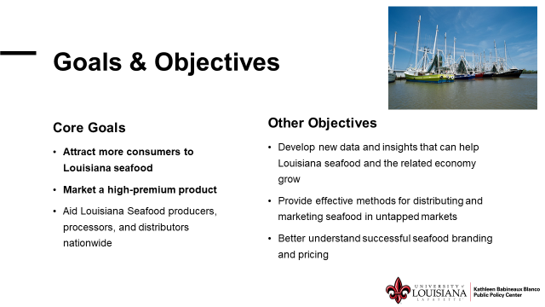

Project Scope and Methods

1. **Analysis of Supply Chains**
   * Interviews with seafood dealers and distributers (including retailers/grocers; restaurants/restaurant services
   * Interview with government procurement contracts directly procuring fresh seafood)
2. **Identify direct-to-consumer channels**
   * Interviews and internet research
3. **Assess broader demand outside Louisiana**
   * Menu price analysis
4. **Compare branding across restaurants**
   * Menu text analysis

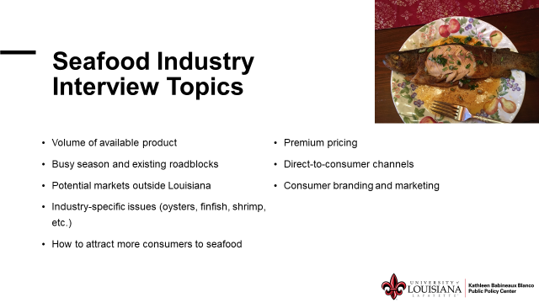

John Tesvich asked if they are going to be working with the LSPMB, will try to incorporate them at some point

1. Earl Melancon provided an update on the LA Sea Grant AOC Grant Project

**Goal:** To supply the Louisiana AOC industry with the necessary financial assistance, education and outreach, and marketing and business tools to increase the opportunity for business success.

**How?** By the end of three years to have **enhanced existing AOC businesses** and increased the number of **new AOC businesses** within the state of Louisiana.

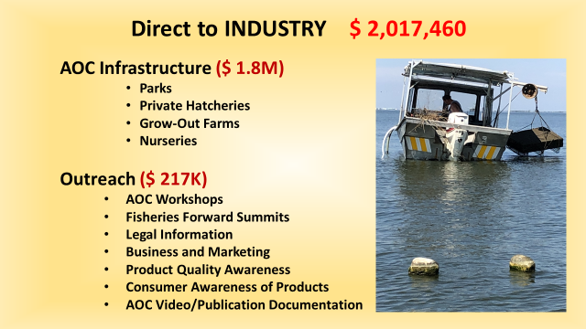

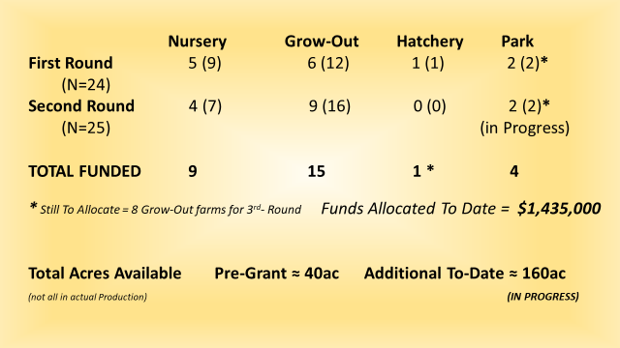

Over the coarse of the next year we are at a point now where we need to be working with the various entities and asking what is needed; will be coming back through the AOC subcommittee those who are interested can provide feedback on moving forward, then the final report is written

Sam Slavich stated that the hand holding aspect of the program is good, especially for the younger people who are newer to the industry and business, what kind of controls do we have on how these people spend the money and what’s the process- Earl Melancon stated that they have a working group of business type people working with the biologists, all puchases under $500 can be reimbursed but before purchased need to know what they are buying, no salaries, no moveable objects like boats, motors, cars, but will pay for modifications on boats to make it AOC friendly, every quarter or every three months they have to show progress or the money will be pulled and the supplies purchased will be taken; Sam Slavich stated that he wants to see what these people are spending and what it is being spent on, Earl Melancon stated that maybe not for the next meeting but for sure for a future meeting he can provide this information

1. The board watched their :30 and :60 second commercials with WWL/TEGNA

Mitch Jurisich stated that the industry may want to continue this commercial running and will discuss further

1. The board discussed the failed Bohemia Salinity Control Structure and closure plans moving forward

Permit application at DNR and moving along, do not have more information since Frank Newell’s passing

Sarah Roy with DNR stated that the permit has been draft authorized and is at the parish for review, there are some conditions in place, one of them is to put a placement of a bond, is in the review phase the P-Number is- P20170422

John Tesvich suggested contacting someone from Plaquemines Parish Government and finding out what is going on with the permit

Mitch Jurisich stated that he would like LDWF to get instrumental in shutting this down

John Tesvich stated that recently the opening of the Neptune Pass across from Buras and now the Corps is involved and they put in a rock sill because the ship captains’ were having issues, hopefully they start assessing all the crevasses along the MS River

Mitch Jurisich requested that LDWF look into the Strategic Plan to dedicate funding to the closure- there is $13M in hydrological funding, really need to try and get something started on this

G. Peter Vujnovich motioned to approve renewing the PR contract with Beuerman Miller Fitzgerald for 12 months, dedicating up to $50,000 in funding, 2nd by Brad Robin. Motion carries.

H. The board discussed the final EIS on the Mid-Barataria Sediment Diversion

Mitch Jurisich stated that they will have to start a strong campaign oppose the project and try and turn things around; this project will see a lot more devastation than what is being projected and portrayed in the EIS; LDWF should be at the forefront of the fight

John Tesvich suggested convening a committee to deal with this topic, bring in BMF on how to deal with this, the board plans to take this up under Coastal Restoration Committee

**VII.** Public Comment

George Ricks stated that part of the issue is that CPRA is telling the general public that we need these diversions to save the coast

**VIII.** Thenext OTF meeting was set for October 11, 2022 for 1pm at the Jean Lafitte Civic Center

**IX.** Brandt Lafrance motioned to adjourn, 2nd by Willie Daisy. Motion carries.